Name____________________________Period________

What is archaeology? What evidence do How do archaeologists
archaeologists look for? collect evidence?
Do...
Evidence...
The Study of...

Who lived in Minnesota before the French (before 1650’s)? _________________________________________

Evidence…

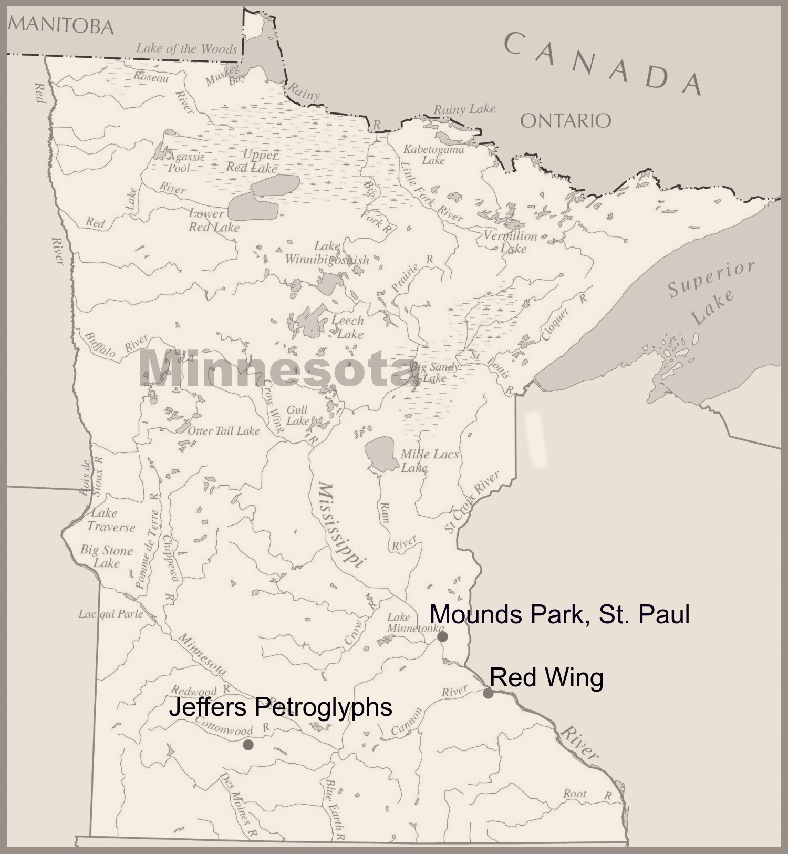
What do you notice about some of the Dakota sites mentioned in the video?

How can archaeologists work with local indigenous people today?

