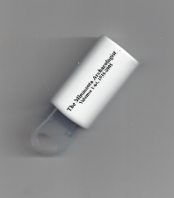 70 YEARS of The MINNESOTA ARCHAEOLOGIST 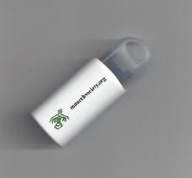
Volumes 1 – 64 (1935 through 2005)
Flash Drive Format
Only $30.00 plus $5.00 shipping and handling.

Name Last: __________________________________________________

First Name and Middle Initial: ___________________________________

Institution: __________________________________________________

Address: ____________________________________________________

City: ____________________________ State: ______ Zip: _____________

Phone: _________________ Fax:_____________ Email:_______________

Make checks or money order payable to
Ft. Snelling History Center
St. Paul, Minnesota 55111

